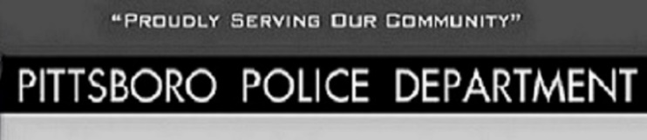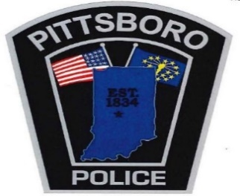
108 West Main Street Office (317) 892-3329
Pittsboro, IN 46167 Fax (317) 892-5632

Chief Scott A. King Major Carl Carson
sking@pittsboropolice.org ccarson@pittsboropolice.org

CASE REPORT REQUEST
CASE#:
HP
DATE OF REPORT:

NAME:

ADDRESS:

- Contact (317) 892-3329 Monday- Friday 8:00 AM - 4:00 PM with case number you are requesting
- A copy of the report requested will be printed off and taken to the Town Hall Office
- $8 Fee is charged for each copy of report requested and is paid at the Pittsboro Town Hall
- Reports can be picked up Monday-Thursday 8:00 AM – 4:00 PM and Fridays 8:00 AM- 11:30 AM

www.crashdocs.org if you need a copy of a vehicle crash

