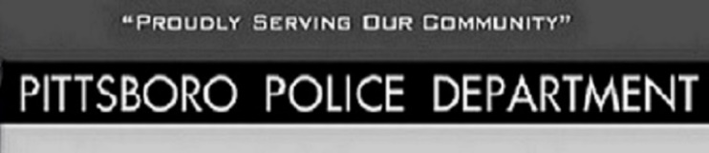
108 West Main Street Office(317) 892-3329
Pittsboro, IN 46167 Fax (317) 892-5632

Chief Scott A. King Major Carl Carson
sking@pittsboropolice.org ccarson@pittsboropolice.org
CITIZEN COMPLAINT
COMPLAINTANT NAME:

COMPLAINTANT ADDRESS:
COMPLAINTANT PHONE:

OFFICER INVOLVED:

DATE OF INCIDENT: TIME OF INCIDENT:

INCIDENT TYPE: TRAFFIC STOP: DISPATCHED TO: OTHER:

DESCRIPTION OF INCIDENT:

PITTSBORO SUPERVISOR:

DATE FILED:
DISPOSITION:

