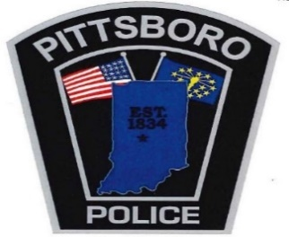
108 West Main Street Office (317) 892-3329
Pittsboro, IN 46167 Fax (317) 892-5632

Chief Scott A. King Major Carl Carson
sking@pittsboropolice.org ccarson@pittsboropolice.org

If you need a copy of a crash report you can obtain it 5-7 days following the incident at www.Crashdocs.org or by notifying your insurance company who will also have access to the crash report

