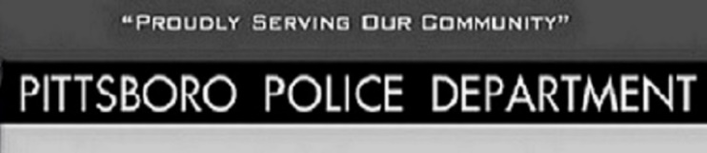
WELFARE CHECK REQUESTS
Report criminal or suspicious activity concerns to:
Emergency 911
Non-Emergency (317) 839-8700
I would suggest giving the (317) 839-8700 to family and friends outside Hendricks County and Indiana so they will be able to request checks on your well being

NAME__________________________________________
ADDRESS_______________________________________
PHONE______________________________
EMERGENCY CONTACT_________________________________ PHONE______________________
INFORMATION FOR FIRST RESPONDERS
______________________________________________________________________________________________________________________________________________________________________________________________________________________________________________________________________________________________________________________________________________________________________________________________________________________________________________________________________________________________________________________________________________________________________________________________________________________________________________________________________________________________________________________________________________________________________________________________________________________________________________________________________________________________________________________________________________________________________________________________________________________________________________________________________________________________________________________________________________________________________________________________________________________________________________________________________________________________________________________________________________________________________________________________________________________________________________________________________________________________________________________________
Return Form Options
Email completed form to: rfrazer@pittsboropolice.org
Pittsboro Police Department or Pittsboro Town Hall Monday – Friday 8:00 AM – 4:00 PM
Bill Pay Drop Box at Pittsboro Town Hall 24/7

